
Implementation of Seamless Layer 2 VPN Connectivity:
A MikroTik-Based MPLS and VPLS Workshop"

SUBASH SUBEDI

Abstract
This project demonstrates the design, configuration, and verification of a Multiprotocol Label Switching (MPLS) core to provide Virtual Private LAN Service (VPLS) using MikroTik RouterOS. The primary objective is to establish a transparent Layer 2 bridge between geographically separated Customer Edge (CE) sites, allowing them to operate within the same broadcast domain over a Provider (P) network.

The implementation utilizes OSPF as the Interior Gateway Protocol (IGP) for core reachability and Label Distribution Protocol (LDP) for signaling and label exchange. Key technical configurations include the optimization of MTU settings (1508 bytes) to prevent fragmentation of encapsulated frames and the binding of VPLS instances to local bridge interfaces on Provider Edge (PE) routers.

The success of the deployment is validated through OSPF adjacency checks, LDP session monitoring, and end-to-end ICMP connectivity between customer sites. Furthermore, a deep-packet analysis via Wireshark confirms the encapsulation of Ethernet frames within MPLS labels (the "inner" and "outer" label stack), proving the core's ability to remain "IP-unaware" while switching customer traffic. This setup serves as a scalable model for Service Providers to offer high-performance site-to-site connectivity.
Table of Contents
1. Introduction 1
2. Prerequisites 1
3. Network Topology Overview 1
4. Configuring the Routers 2
4.1 Main Router Configuration 2
4.2 PE1 Router Configuration 10
4.3 PE2 Router Configuration 19
4.4 CE1 Router Configuration 27
4.5 CE2 Router Configuration 29
5. Verifying the MPLS and VPLS Setup 31
6. Troubleshooting Common Issues 34
7. Wireshark Traffic 35
7.1 Identify basic protocols first 35
7.2 Check OSPF (control plane) 35
7.3 Verify OSPF Neighbor formation 36
7.4 Check MPLS packets 37
7.5 Check LDP (Label Distribution Protocol) 38
7.6 Verify VPLS traffic 39
7.7 Check MAC learning (important for VPLS) 40
8. Conclusion 42

List of Figures
Figure 1 1
Figure 2 : CMD to set Identity and Loopback (Main Router) 2
Figure 3: WINBOX to set Identity and Loopback (Main Router) 2
Figure 4: CMD to set Core Interface IPs (Connecting to PE1 and PE2) (Main Router) 3
Figure 5: WINBOX Process to set Core Interface IPs (Connecting to PE1 and PE2) (Main Router) 3
Figure 6:CMD for OSPF setup (Main Router) 4
Figure 7: WINBOX Process OSPF SETUP (Main Router) 5
Figure 8: WINBOX Process for OSPF SETUP (Main Router) 5
Figure 9: WINBOX Process for OSPF SETUP (Main Router) 6
Figure 10: CMD to setup  MPLS and LDP (Main Router) 6
Figure 11: WINBOX Process for Setup MPLS and LDP (Main Router) 7
Figure 12: CMD to Enable LDP on Interfaces (Main Router) 7
Figure 13: WINBOX Process to Enable LDP on Interfaces (Main Router) 8
Figure 14: CMD to Setup MPLS MTU (Crucial for VPLS to prevent fragmentation) i (Main Router) 9
Figure 15: CMD to Setup MPLS MTU (Crucial for VPLS to prevent fragmentation) ii (Main Router) 9
Figure 16: WINBOX to Setup MPLS MTU (Crucial for VPLS to prevent fragmentation) ii (Main Router) 9
Figure 17: CMD to Set Identity and Loopback (PE1 Router) 10
Figure 18: WINBOX Process to Set Identity and Loopback (PE1 Router) 10
Figure 19: CMD to set Interface Ips (PE1 Router) 11
Figure 20: WINBOX Process to set Interface IPs (PE1 Router) 11
Figure 21: CMD for OSPF Setup (PE1 Router) 12
Figure 22: WINBOX Process for OSPF Setup i (PE1 Router) 12
Figure 23: WINBOX Process for OSPF Setup ii (PE1 Router) 12
Figure 24: WINBOX Process for OSPF Setup iii (PE1 Router) 13
Figure 25: CMD to Setup MPLS & LDP (PE1 Router) 14
Figure 26: WINBOX Process for Setup MPLS & LDP i (PE1 Router) 14
Figure 27: WINBOX Process for Setup MPLS & LDP ii (PE1 Router) 15
Figure 28: CMD for VPLS Setup (Note: 'peer' instead of 'remote-peer') (PE1 Router) 15
Figure 29: WINBOX Process for VPLS Setup (Note: 'peer' instead of 'remote-peer') (PE1 Router) 16
Figure 30:CMD to Setup Customer Bridge (Binds the VPLS tunnel to the Customer Port) (PE1 Router) 16
Figure 31: WINBOX for Setup Customer Bridge (Binds the VPLS tunnel to the Customer Port) (PE1 Router) 17
Figure 32: CMD to Setup MPLS MTU (PE1 Router) 17
Figure 33: WINBOX for Setup MPLS MTU (PE1 Router) 18
Figure 34: CMD to Set Identity and Loopback (PE2 Router) 19
Figure 35: WINBOX Process to Set Identity and Loopback (PE2 Router) 19
Figure 36: CMD to set Interface Ips (PE1 Router) 20
Figure 37: WINBOX Process to set Interface IPs (PE1 Router) 20
Figure 38: CMD for OSPF Setup (PE2 Router) 20
Figure 39: WINBOX Process for OSPF Setup i (PE2 Router) 21
Figure 40: WINBOX Process for OSPF Setup ii (PE2 Router) 21
Figure 41: WINBOX Process for OSPF Setup iii (PE2 Router) 22
Figure 42: CMD to Setup MPLS & LDP (PE2 Router) 22
Figure 43: WINBOX Process for Setup MPLS & LDP i (PE2 Router) 23
Figure 44: WINBOX Process for Setup MPLS & LDP ii (PE2 Router) 23
Figure 45: CMD for VPLS Setup (Note: 'peer' instead of 'remote-peer') (PE2 Router) 23
Figure 46: WINBOX Process for VPLS Setup (Note: 'peer' instead of 'remote-peer') (PE2 Router) 24
Figure 47: CMD to Setup Customer Bridge (Binds the VPLS tunnel to the Customer Port) (PE2 Router) 24
Figure 48: WINBOX for Setup Customer Bridge (Binds the VPLS tunnel to the Customer Port) (PE2 Router) 25
Figure 49: CMD to Setup MPLS MTU (PE2 Router) 25
Figure 50: WINBOX for Setup MPLS MTU (PE2 Router) 26
Figure 51: CMD to Steup Identity 27
Figure 52: WINBOX for set Identity 27
Figure 53: CMD to Setup Interface IP and Route 28
Figure 54: WINBOX to Steup Interface IP and Route 28
Figure 55: CMD to Steup Identity 29
Figure 56: WINBOX for set Identity 29
Figure 57: CMD to Setup Interface IP and Route 29
Figure 58: WINBOX to Steup Interface IP and Route 30
Figure 59: Output of ospf neighbor Main Router 31
Figure 60: Output of ospf neighbor PE1 Router 31
Figure 61: Output of ospf neighbor PE2 Router 31
Figure 62: Output of ldp neighbor Main Router 31
Figure 63: Output of ldp neighbor PE1 Router 32
Figure 64: Output of ldp neighbor PE2 Router 32
Figure 65: Output of vpls monitor PE1 Router 32
Figure 66: Output of vpls monitor PE2 Router 32
Figure 67: CE1 PING and TRACEROUTE Report 33
Figure 68: CE2 PING and TRACEROUTE Report 33
Figure 69 35
Figure 70 36
Figure 71 37
Figure 72 38
Figure 73 39
Figure 74 41

Introduction
This document provides a comprehensive guide to setting up MPLS (Multiprotocol Label Switching) and VPLS (Virtual Private LAN Service) on MikroTik routers using GNS3. The setup consists of a Provider (P) router (Main), two Provider Edge (PE) routers, and two Customer Edge (CE) routers. VPLS creates a transparent Layer 2 Ethernet bridge, allowing CE1 and CE2 to communicate on the same subnet across an MPLS core.

Prerequisites
Emulation: GNS3
Images: MikroTik CHR v7.x (Tested on 7.21rc4).
Protocol Knowledge: OSPF (IGP), LDP (Label Distribution), and VPLS (Tunneling).

Network Topology Overview
Main (P): Loopback 1.1.1.1/32
PE1: Loopback 2.2.2.2/32 | PE2: Loopback 3.3.3.3/32
CE1: 192.168.10.1/24 | CE2: 192.168.10.2/24
Core Links: * Main (ether1) to PE1 (ether1): 10.0.1.0/30

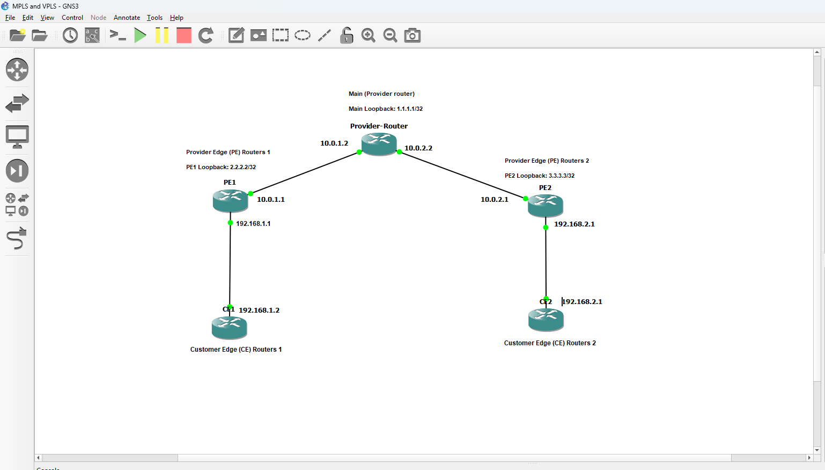
Figure 1

Configuring the Routers
Configurations are provided in RouterOS CLI format. Apply them via terminal or export/import scripts.

Main Router Configuration
The Main router handles label switching between PE1 and PE2..

- Set Identity and Loopback:
/system identity set name=Main
/interface bridge add name=loopback
/ip address add address=1.1.1.1/32 interface=loopback

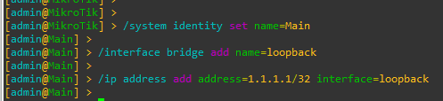
Figure 2 : CMD to set Identity and Loopback (Main Router)
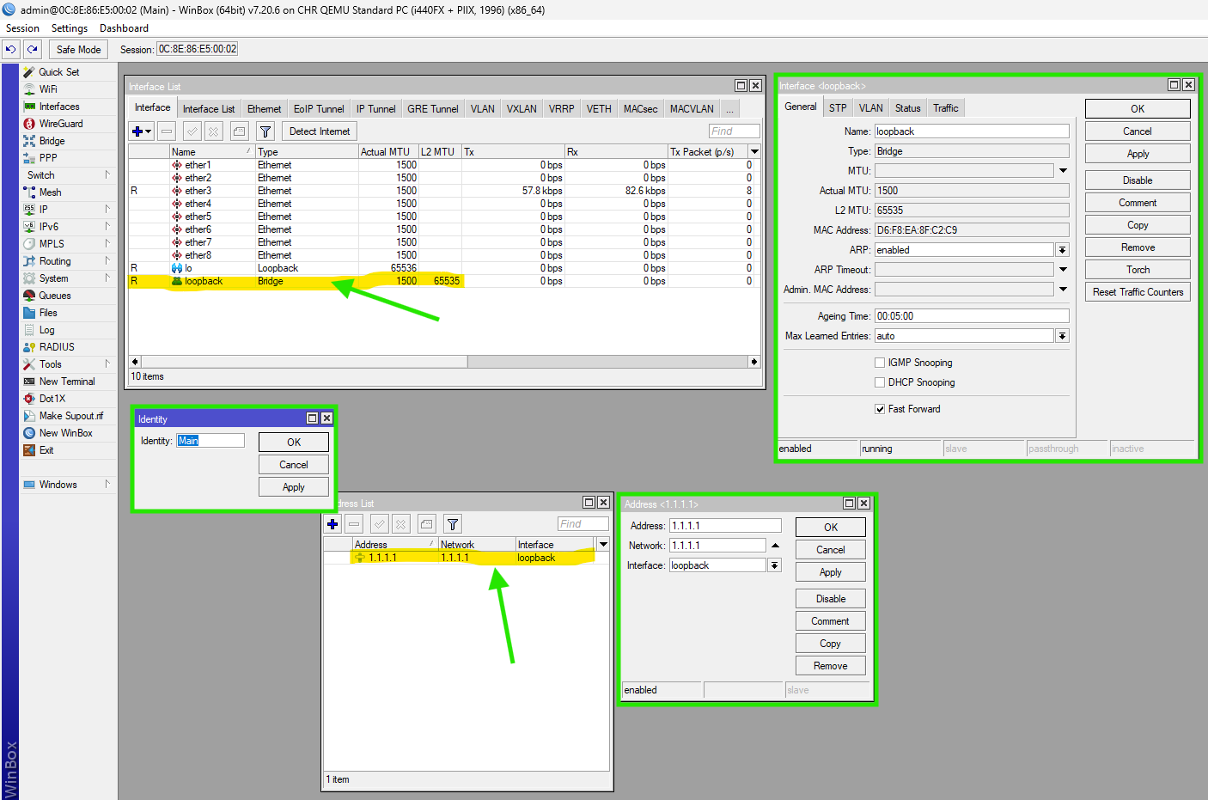
Figure 3: WINBOX to set Identity and Loopback (Main Router)
- Core Interface IPs (Connecting to PE1 and PE2):
/ip address add address=10.0.1.2/30 interface=ether1 comment="To PE1"

/ip address add address=10.0.2.2/30 interface=ether2 comment="To PE2"

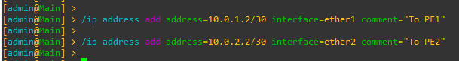
Figure 4: CMD to set Core Interface IPs (Connecting to PE1 and PE2) (Main Router)

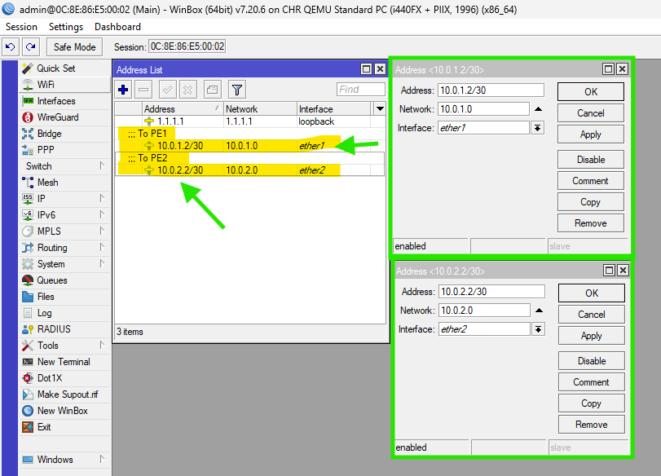
Figure 5: WINBOX Process to set Core Interface IPs (Connecting to PE1 and PE2) (Main Router)

- OSPF Setup:
/routing ospf instance add name=default-v7 router-id=1.1.1.1
/routing ospf area add name=backbone area-id=0.0.0.0 instance=default-v7

/routing ospf interface-template
add interfaces=loopback area=backbone passive
add interfaces=ether1 area=backbone
add interfaces=ether2 area=backbone

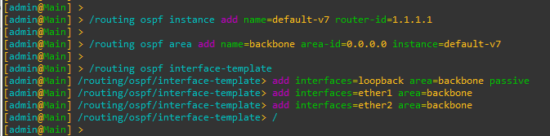
Figure 6:CMD for OSPF setup (Main Router)

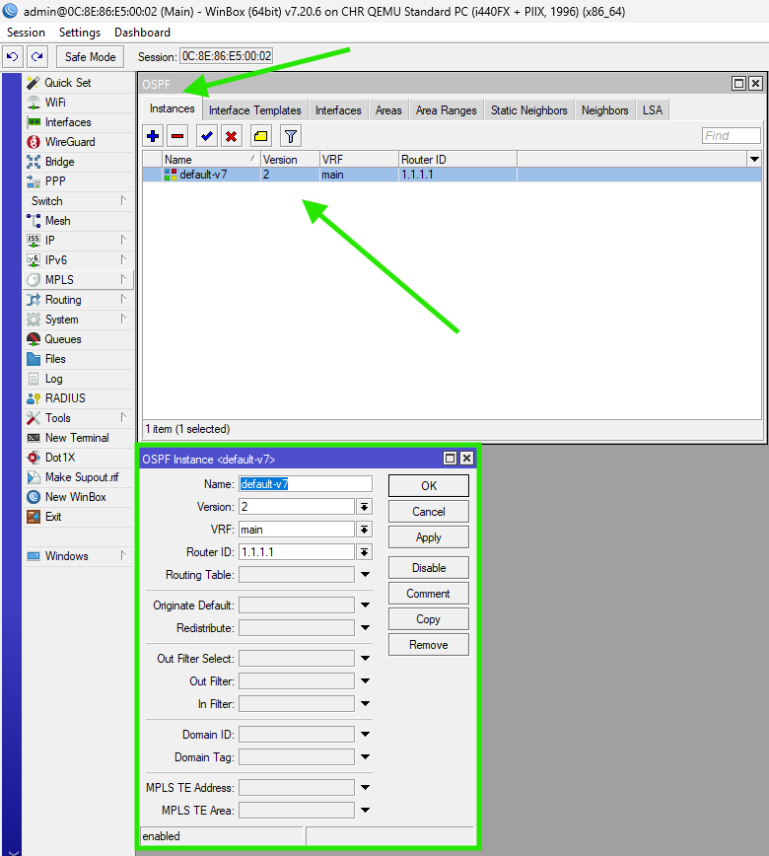
Figure 7: WINBOX Process OSPF SETUP (Main Router)
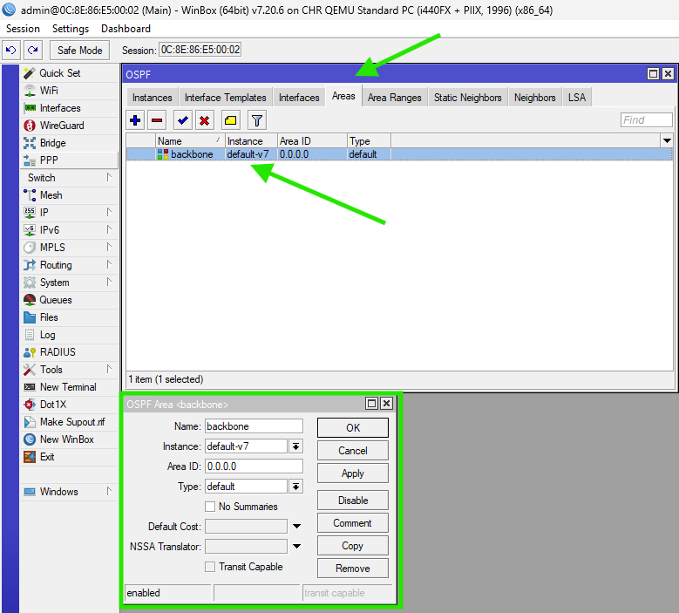
Figure 8: WINBOX Process for OSPF SETUP (Main Router)

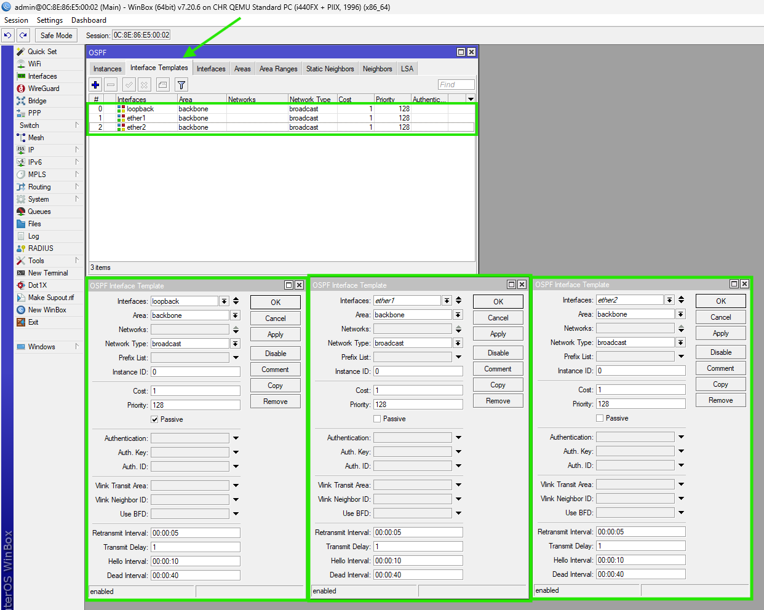
Figure 9: WINBOX Process for OSPF SETUP (Main Router)

- MPLS and LDP:
/mpls ldp add lsr-id=1.1.1.1 transport-addresses=1.1.1.1
/mpls ldp set [find lsr-id=1.1.1.1] disabled=no

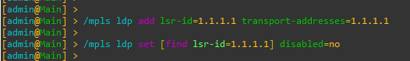
Figure 10: CMD to setup  MPLS and LDP (Main Router)

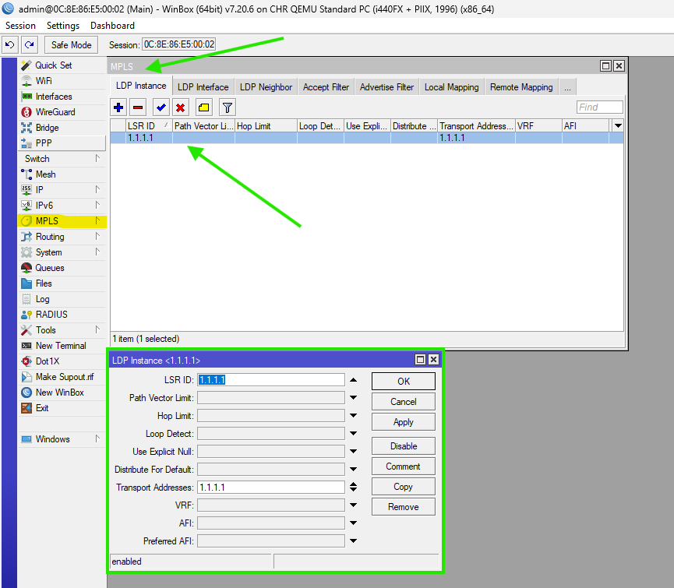
Figure 11: WINBOX Process for Setup MPLS and LDP (Main Router)

- Enable LDP on Interfaces
/mpls ldp interface add interface=ether1
/mpls ldp interface add interface=ether2

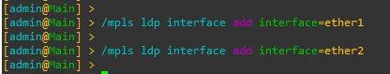
Figure 12: CMD to Enable LDP on Interfaces (Main Router)

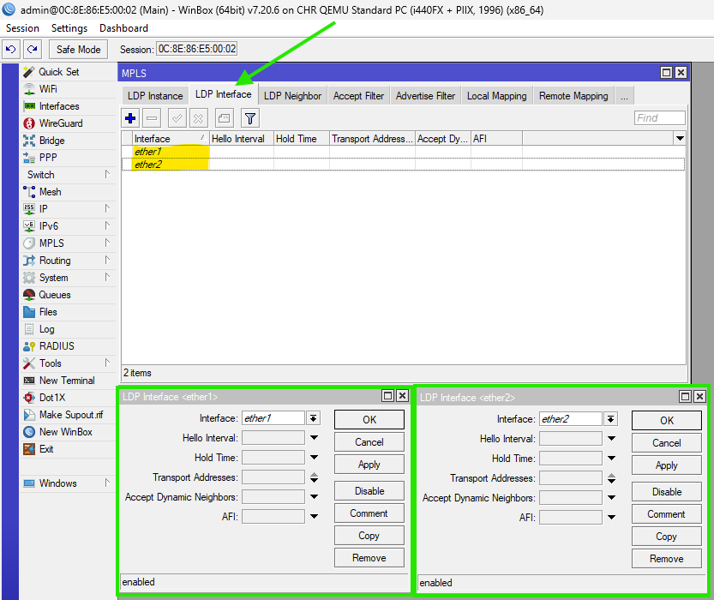
Figure 13: WINBOX Process to Enable LDP on Interfaces (Main Router)

- Set MPLS MTU (Crucial for VPLS to prevent fragmentation)
/mpls interface set [find where interface=ether1] mpls-mtu=1508
/mpls interface set [find where interface=ether2] mpls-mtu=1508

Or

/mpls interface add interface=ether1 mpls-mtu=1508
/mpls interface add interface=ether2 mpls-mtu=1508

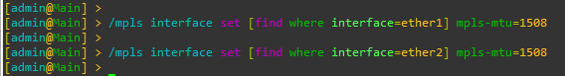
Figure 14: CMD to Setup MPLS MTU (Crucial for VPLS to prevent fragmentation) i (Main Router)

Figure 15: CMD to Setup MPLS MTU (Crucial for VPLS to prevent fragmentation) ii (Main Router)

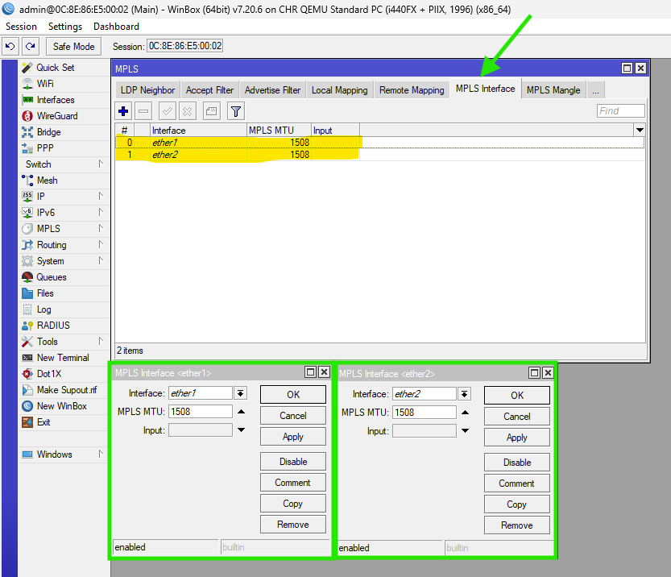
Figure 16: WINBOX to Setup MPLS MTU (Crucial for VPLS to prevent fragmentation) ii (Main Router)

PE1 Router Configuration
PE1 bridges the local customer (CE1) into the MPLS VPLS tunnel.

- Set Identity and Loopback:
/system identity set name=PE1
/interface bridge add name=loopback
/ip address add address=2.2.2.2/32 interface=loopback

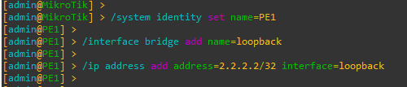
Figure 17: CMD to Set Identity and Loopback (PE1 Router)

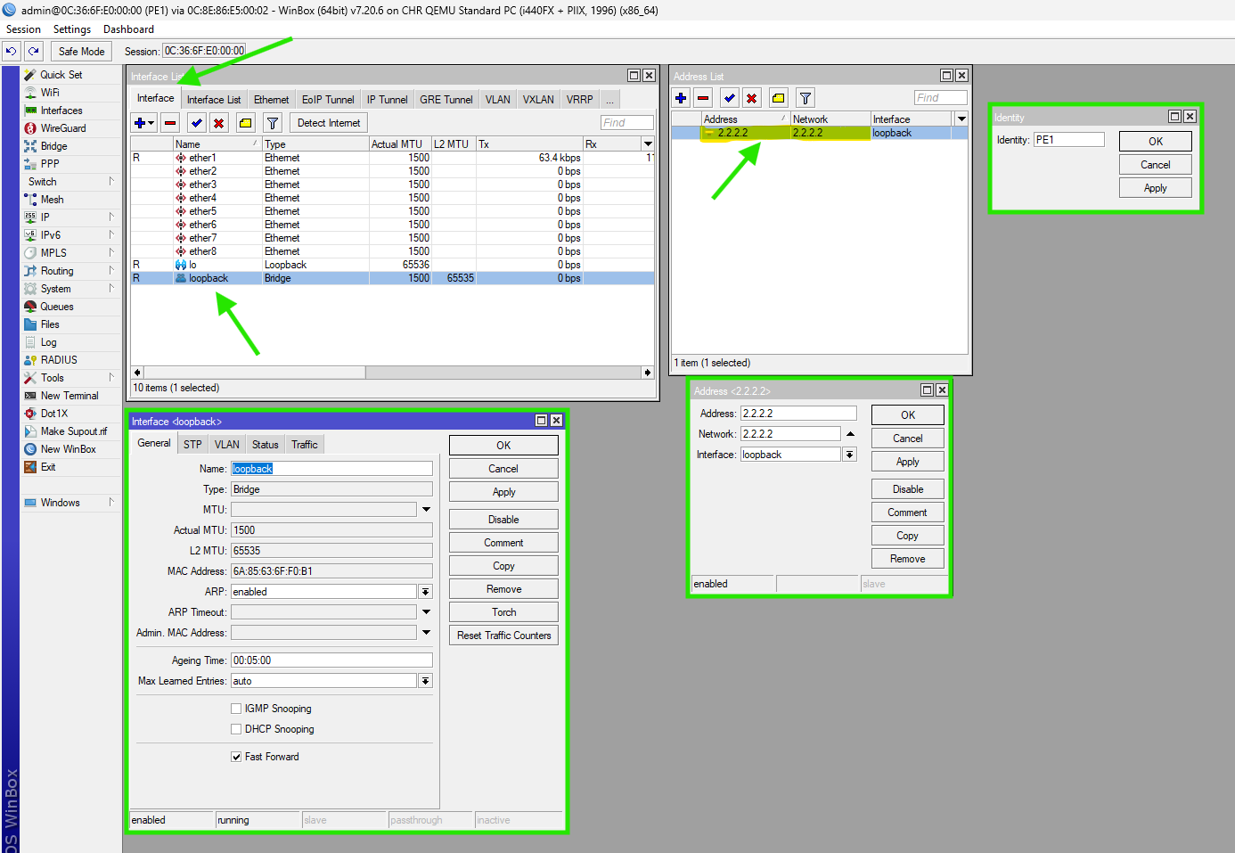
Figure 18: WINBOX Process to Set Identity and Loopback (PE1 Router)

- Interface IPs:
/ip address add address=10.0.1.1/30 interface=ether1 comment="Connect to Main"

Figure 19: CMD to set Interface Ips (PE1 Router)

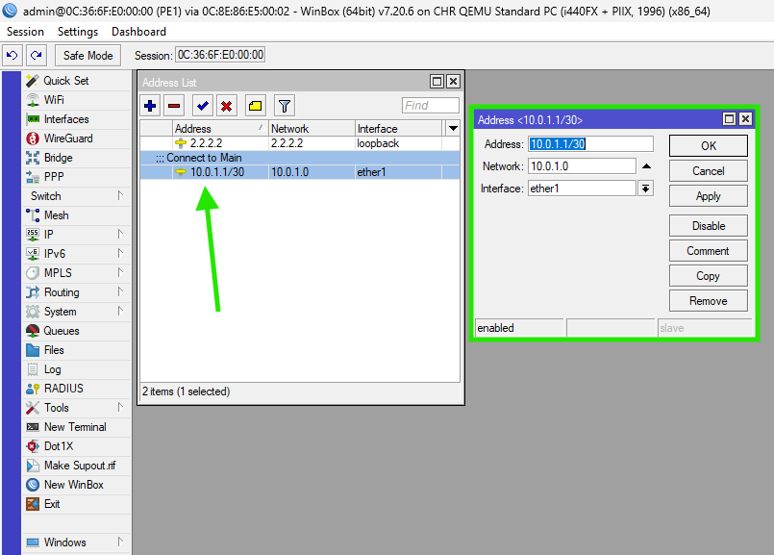
Figure 20: WINBOX Process to set Interface IPs (PE1 Router)

- OSPF Setup (To reach Main and PE2):
/routing ospf instance add name=default-v7 router-id=2.2.2.2
/routing ospf area add name=backbone area-id=0.0.0.0 instance=default-v7
/routing ospf interface-template
add interfaces=loopback area=backbone passive
add interfaces=ether1 area=backbone

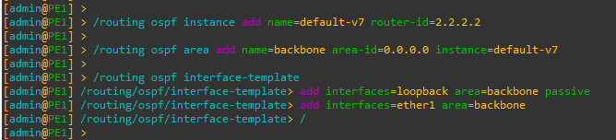
Figure 21: CMD for OSPF Setup (PE1 Router)

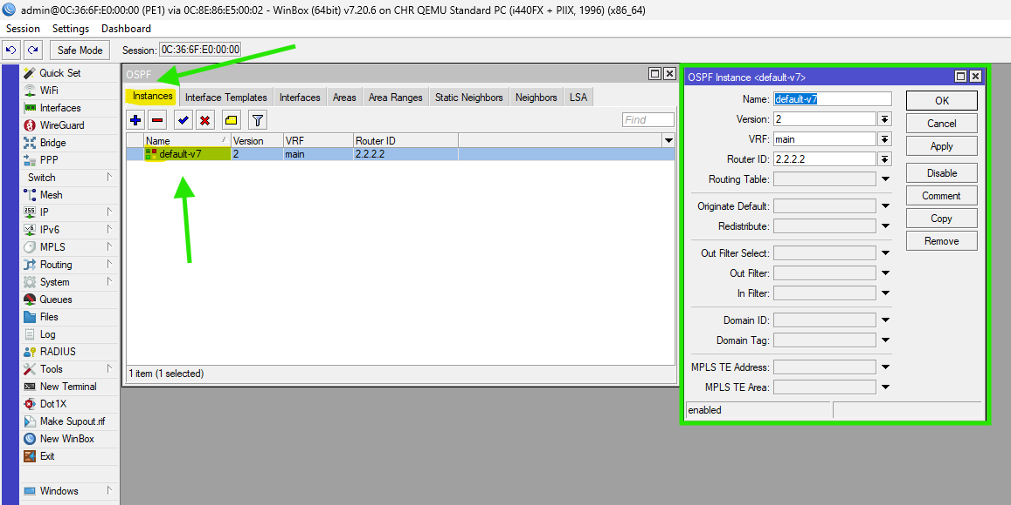
Figure 22: WINBOX Process for OSPF Setup i (PE1 Router)

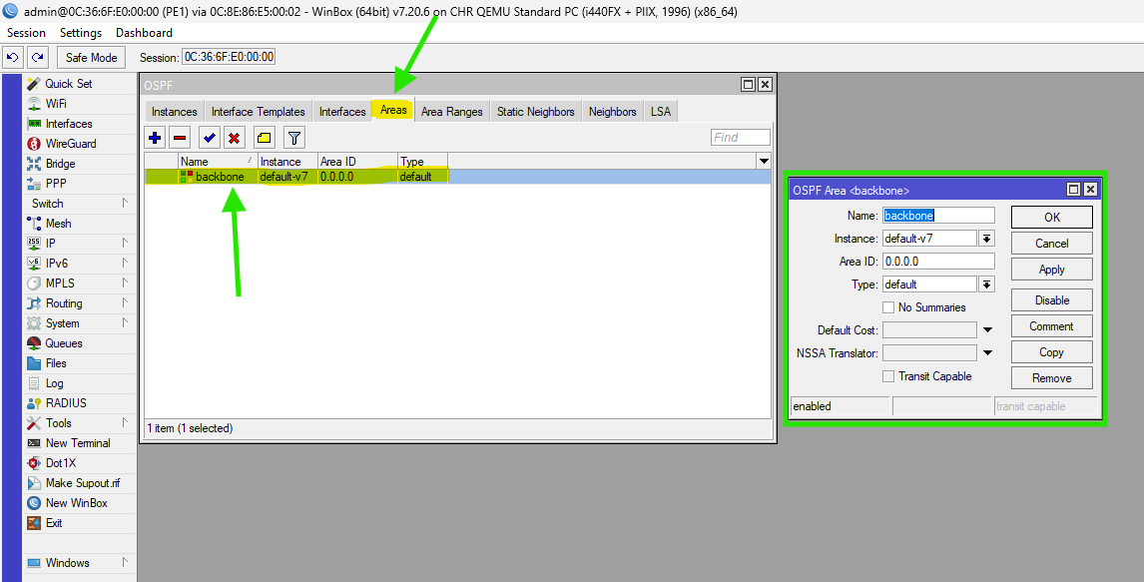
Figure 23: WINBOX Process for OSPF Setup ii (PE1 Router)
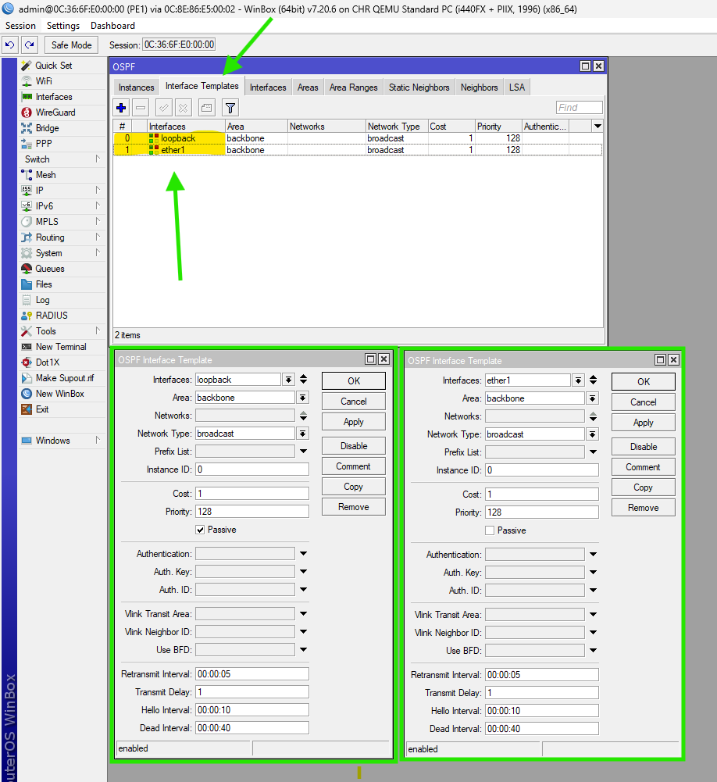
Figure 24: WINBOX Process for OSPF Setup iii (PE1 Router)

- MPLS and LDP:
/mpls ldp add lsr-id=2.2.2.2 transport-addresses=2.2.2.2
/mpls ldp set [find lsr-id=2.2.2.2] disabled=no
/mpls ldp interface add interface=ether1

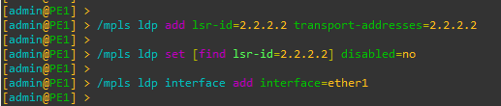
Figure 25: CMD to Setup MPLS & LDP (PE1 Router)

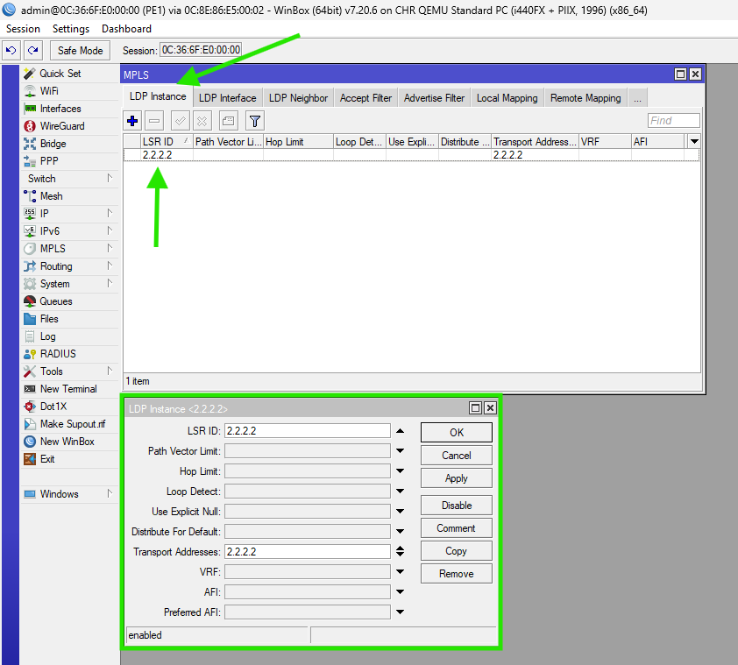
Figure 26: WINBOX Process for Setup MPLS & LDP i (PE1 Router)

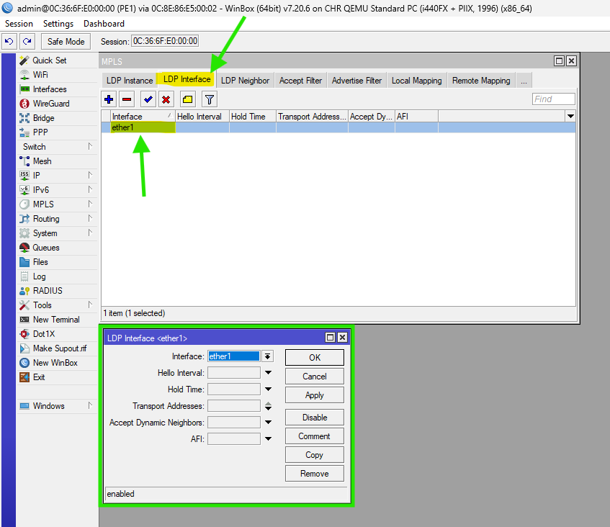
Figure 27: WINBOX Process for Setup MPLS & LDP ii (PE1 Router)

- VPLS Setup (Note: 'peer' instead of 'remote-peer'):
/interface vpls add name=vpls1 peer=3.3.3.3 vpls-id=10:1 disabled=no

Figure 28: CMD for VPLS Setup (Note: 'peer' instead of 'remote-peer') (PE1 Router)

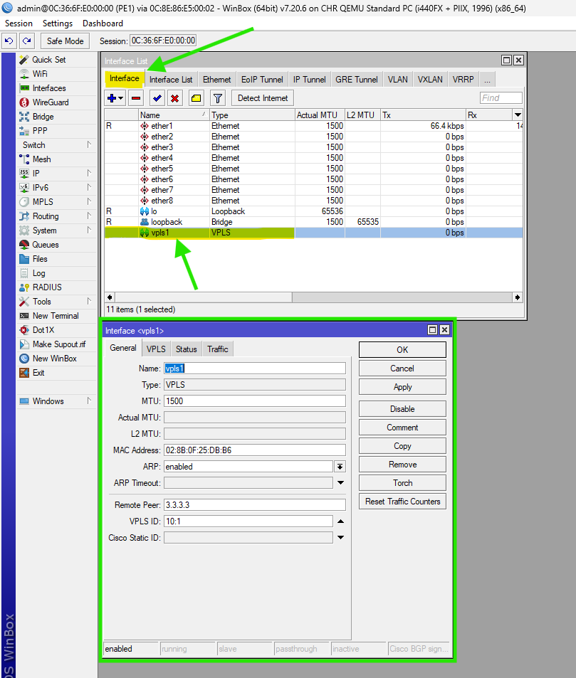
Figure 29: WINBOX Process for VPLS Setup (Note: 'peer' instead of 'remote-peer') (PE1 Router)

- Customer Bridge (Binds the VPLS tunnel to the Customer Port):
/interface bridge add name=br-customer
/interface bridge port add bridge=br-customer interface=ether2
/interface bridge port add bridge=br-customer interface=vpls1

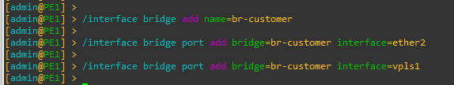
Figure 30:CMD to Setup Customer Bridge (Binds the VPLS tunnel to the Customer Port) (PE1 Router)

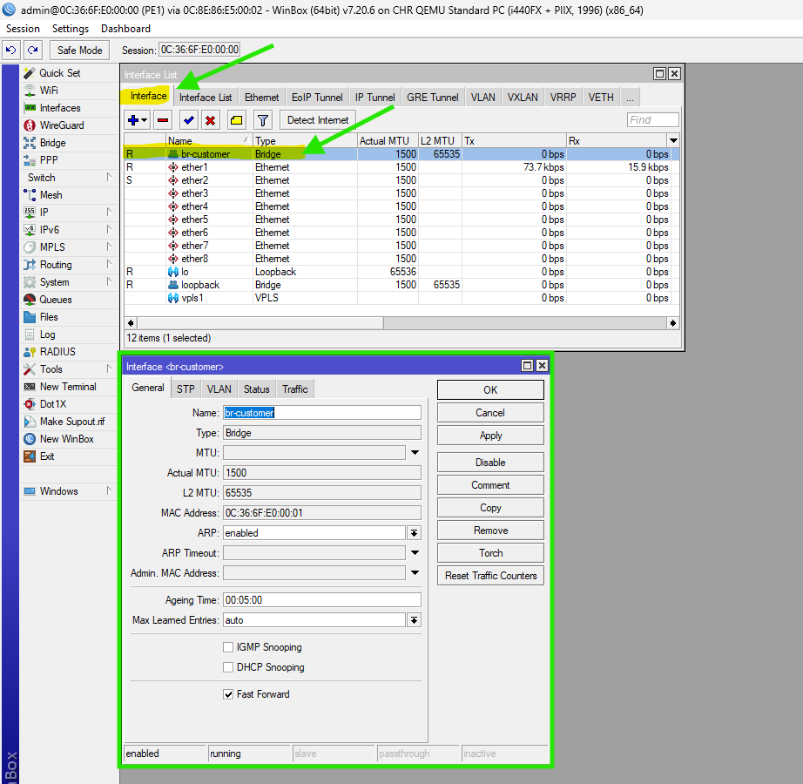
Figure 31: WINBOX for Setup Customer Bridge (Binds the VPLS tunnel to the Customer Port) (PE1 Router)

- MPLS MTU
/mpls interface set [find where interface=ether1] mpls-mtu=1508
Or
/mpls interface add interface=ether1 mpls-mtu=1508

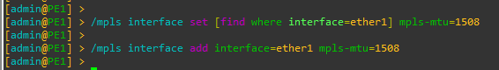
Figure 32: CMD to Setup MPLS MTU (PE1 Router)
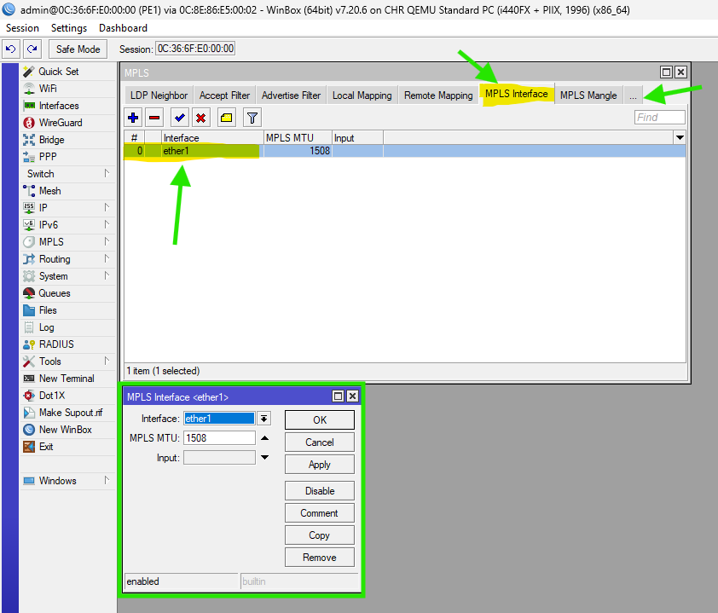
Figure 33: WINBOX for Setup MPLS MTU (PE1 Router)

PE2 Router Configuration
Like PE1, but adjusted IPs and remote-peer.

- Set Identity and Loopback:
/system identity set name=PE2
/interface bridge add name=loopback
/ip address add address=3.3.3.3/32 interface=loopback

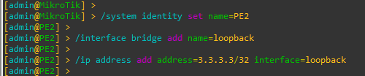
Figure 34: CMD to Set Identity and Loopback (PE2 Router)

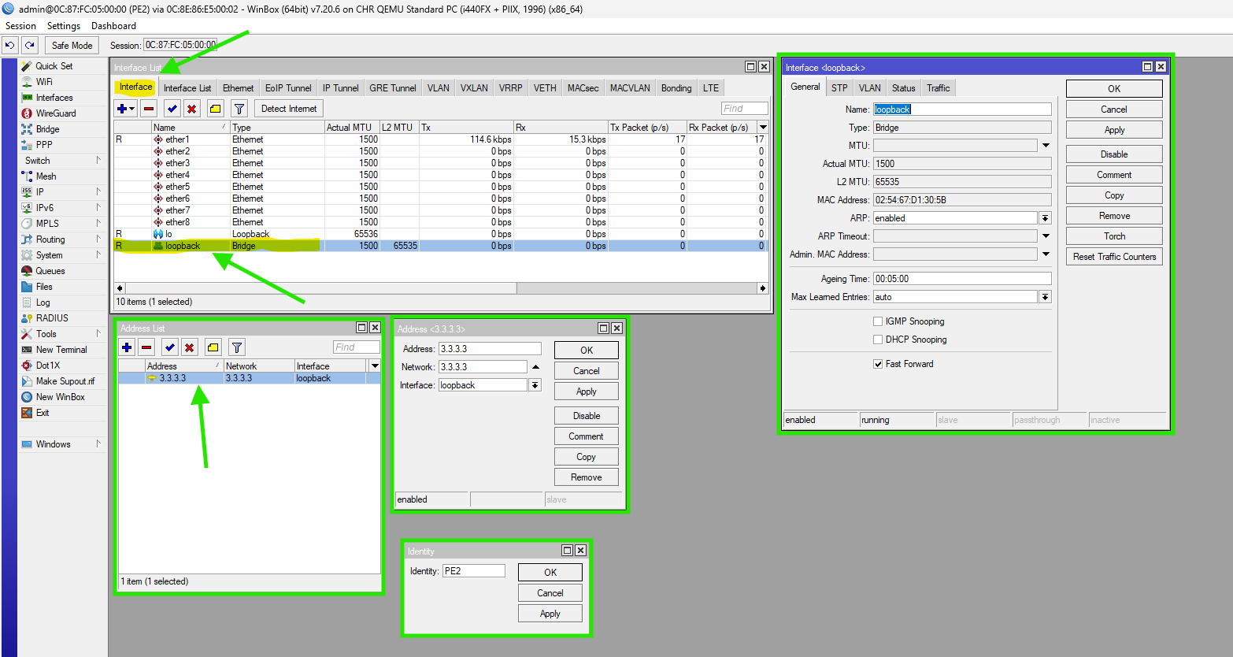
Figure 35: WINBOX Process to Set Identity and Loopback (PE2 Router)

- IP Addressing (Core side):
/ip address add address=10.0.2.1/30 interface=ether1 comment="Connect to Main"

Figure 36: CMD to set Interface Ips (PE1 Router)

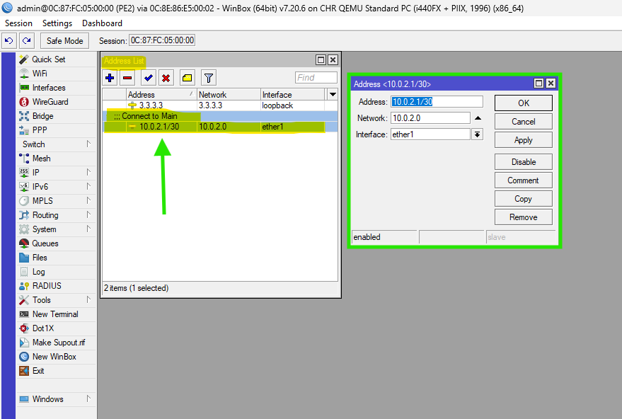
Figure 37: WINBOX Process to set Interface IPs (PE1 Router)

- OSPF Setup:
/routing ospf instance add name=default-v7 router-id=3.3.3.3
/routing ospf area add name=backbone area-id=0.0.0.0 instance=default-v7
/routing ospf interface-template
add interfaces=loopback area=backbone passive
add interfaces=ether1 area=backbone

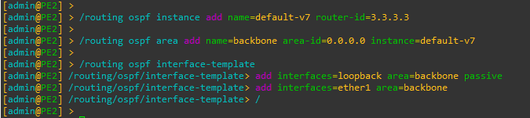
Figure 38: CMD for OSPF Setup (PE2 Router)

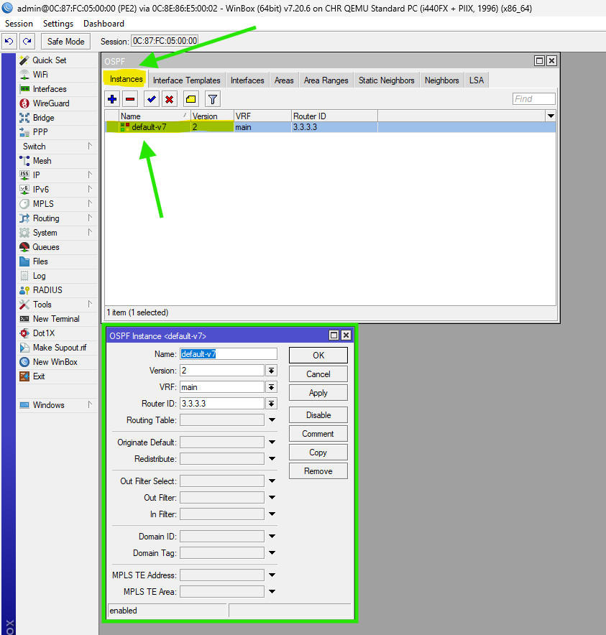
Figure 39: WINBOX Process for OSPF Setup i (PE2 Router)

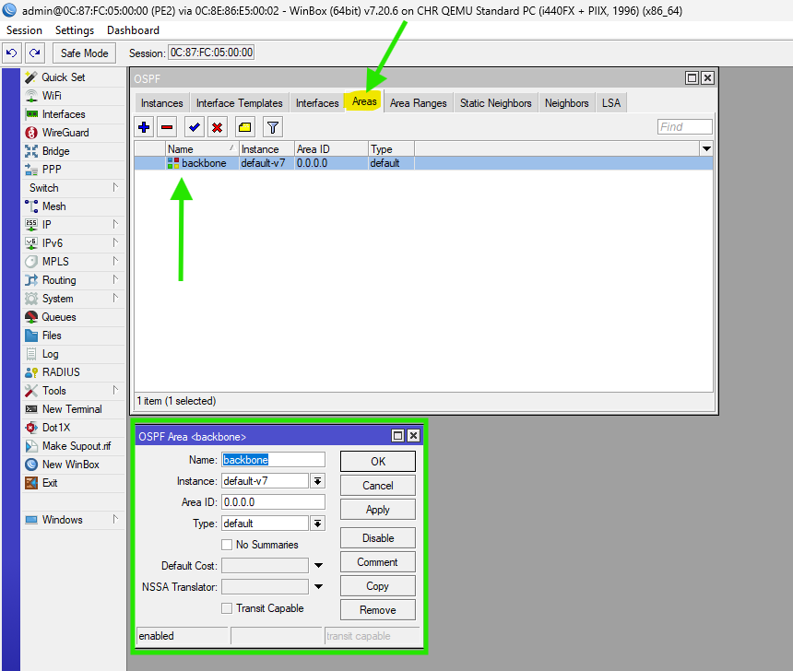
Figure 40: WINBOX Process for OSPF Setup ii (PE2 Router)

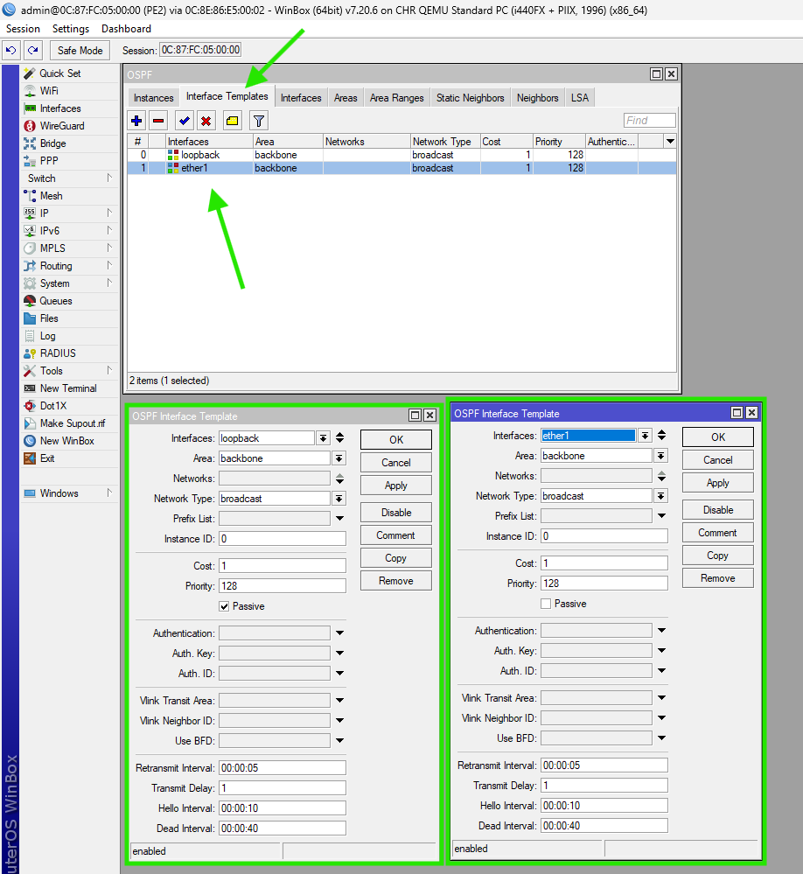
Figure 41: WINBOX Process for OSPF Setup iii (PE2 Router)

- MPLS and LDP:
/mpls ldp add lsr-id=3.3.3.3 transport-addresses=3.3.3.3
/mpls ldp set [find lsr-id=3.3.3.3] disabled=no
/mpls ldp interface add interface=ether1

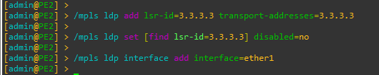
Figure 42: CMD to Setup MPLS & LDP (PE2 Router)
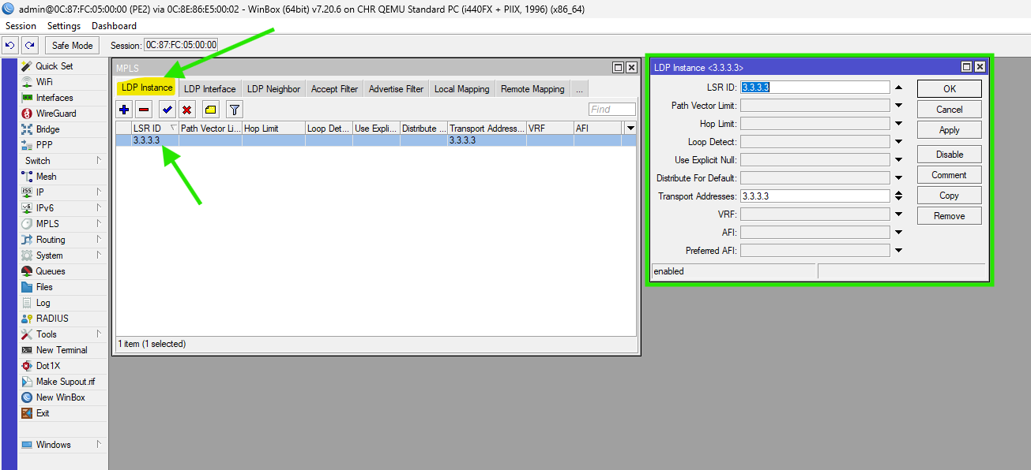
Figure 43: WINBOX Process for Setup MPLS & LDP i (PE2 Router)

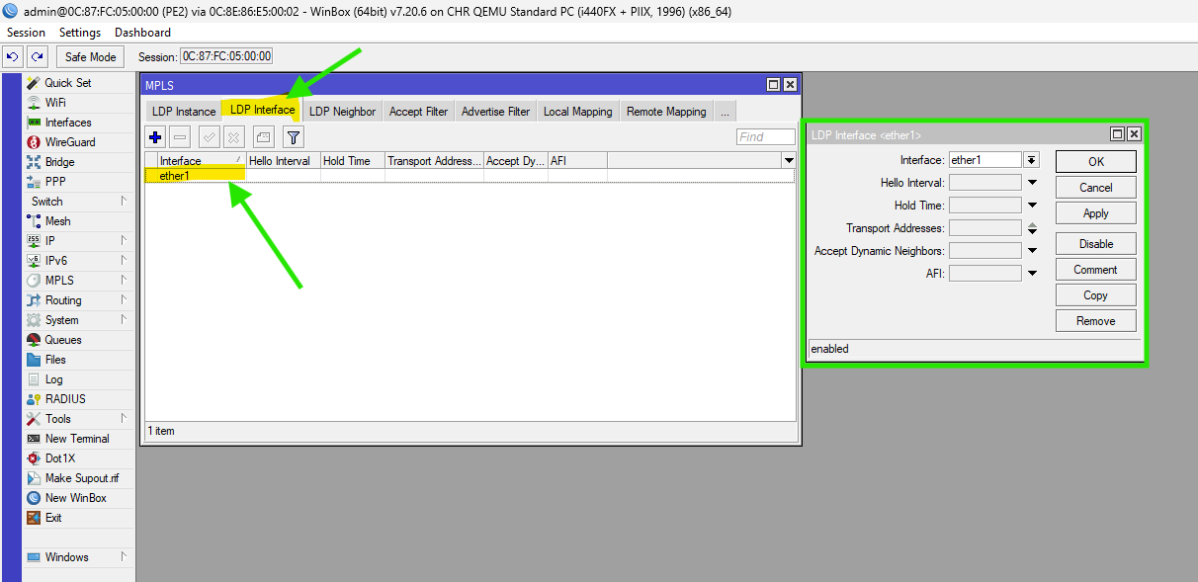
Figure 44: WINBOX Process for Setup MPLS & LDP ii (PE2 Router)

- VPLS Setup (Points to PE1: 2.2.2.2):
/interface vpls add name=vpls1 peer=2.2.2.2 vpls-id=10:1 disabled=no

Figure 45: CMD for VPLS Setup (Note: 'peer' instead of 'remote-peer') (PE2 Router)

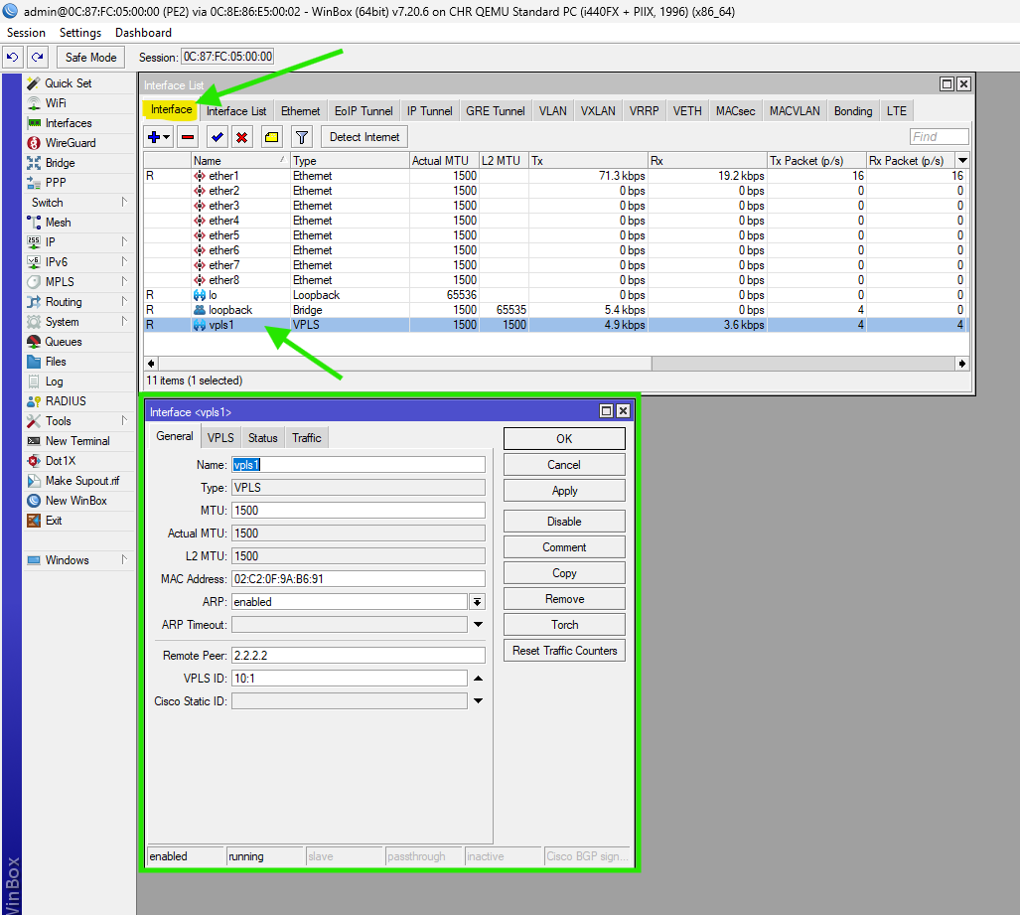
Figure 46: WINBOX Process for VPLS Setup (Note: 'peer' instead of 'remote-peer') (PE2 Router)

- Customer Bridge:
/interface bridge add name=br-customer
/interface bridge port add bridge=br-customer interface=ether2
/interface bridge port add bridge=br-customer interface=vpls1

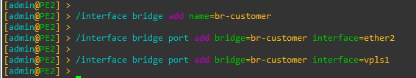
Figure 47: CMD to Setup Customer Bridge (Binds the VPLS tunnel to the Customer Port) (PE2 Router)

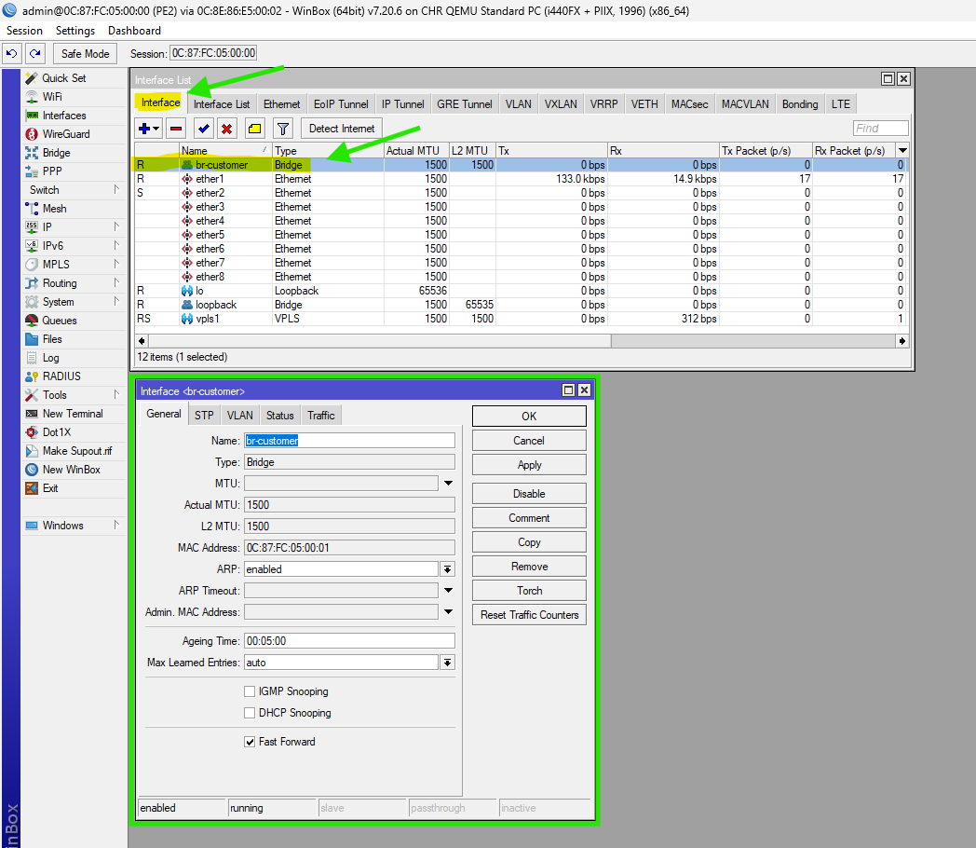
Figure 48: WINBOX for Setup Customer Bridge (Binds the VPLS tunnel to the Customer Port) (PE2 Router)

- MPLS MTU
/mpls interface set [find where interface=ether1] mpls-mtu=1508
Or
/mpls interface add interface=ether1 mpls-mtu=1508

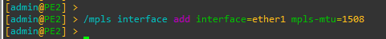
Figure 49: CMD to Setup MPLS MTU (PE2 Router)
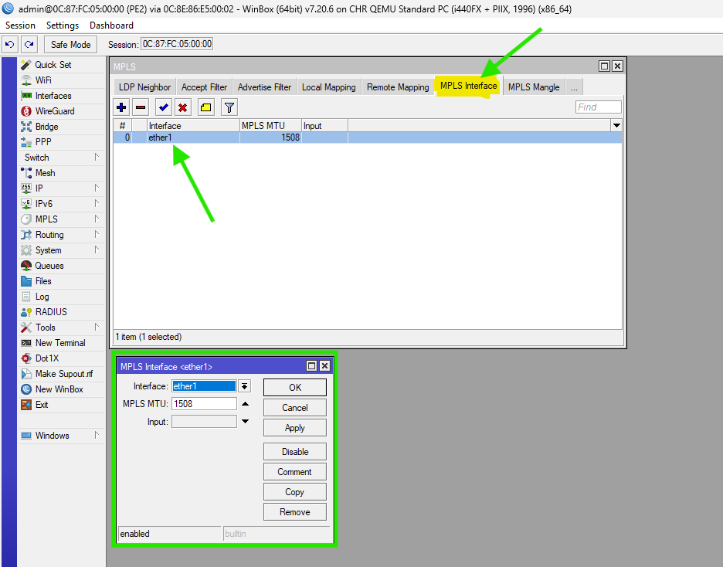
Figure 50: WINBOX for Setup MPLS MTU (PE2 Router)

CE1 Router Configuration
Assuming CE1 is also a MikroTik for simplicity (use similar for other routers).

- Set Identity:
/system identity set name=CE1

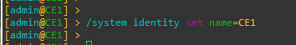
Figure 51: CMD to Steup Identity

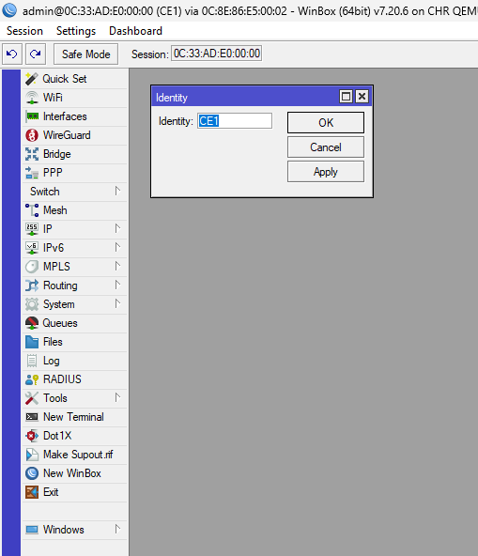
Figure 52: WINBOX for set Identity

- Interface IP and Route:
/ip address add address=192.168.10.1/24 interface=ether1

Figure 53: CMD to Setup Interface IP and Route

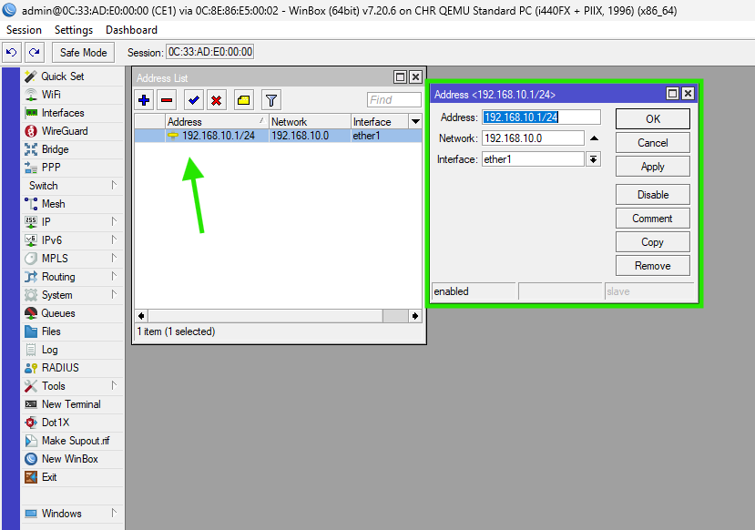
Figure 54: WINBOX to Steup Interface IP and Route

CE2 Router Configuration
Assuming CE2 is also a MikroTik for simplicity (use similar for other routers).

- Set Identity:
/system identity set name=CE2

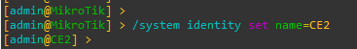
Figure 55: CMD to Steup Identity
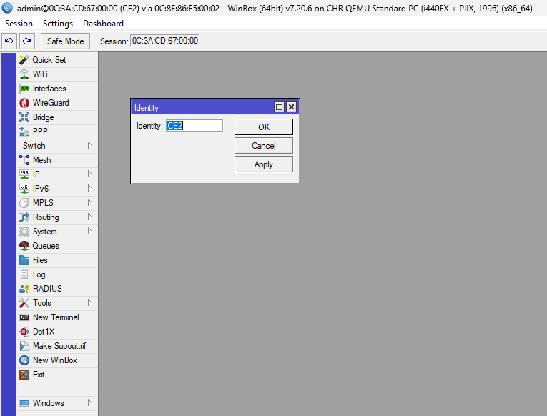
Figure 56: WINBOX for set Identity

- Interface IP (Shared Subnet):
/ip address add address=192.168.10.2/24 interface=ether1

Figure 57: CMD to Setup Interface IP and Route

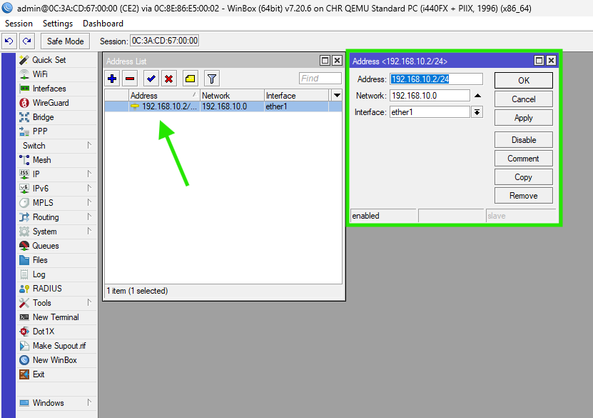
Figure 58: WINBOX to Steup Interface IP and Route

Verifying the MPLS and VPLS Setup
OSPF Adjacency: Run /routing ospf neighbor print. All core links must show state="Full".

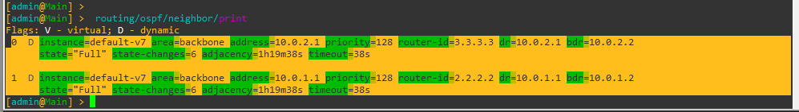
Figure 59: Output of ospf neighbor Main Router

Figure 60: Output of ospf neighbor PE1 Router

Figure 61: Output of ospf neighbor PE2 Router

LDP Session: Run /mpls ldp neighbor print. Should show DO (Dynamic, Operational) flags.
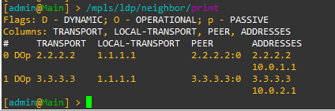
Figure 62: Output of ldp neighbor Main Router

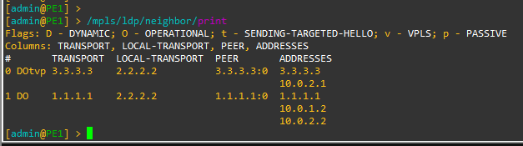
Figure 63: Output of ldp neighbor PE1 Router

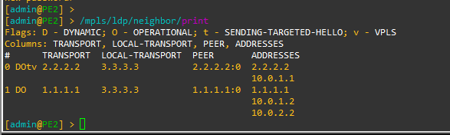
Figure 64: Output of ldp neighbor PE2 Router

VPLS Tunnel: Run /interface vpls monitor vpls1. Should show remote-label and status: running.

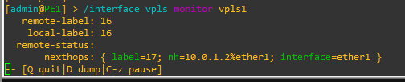
Figure 65: Output of vpls monitor PE1 Router

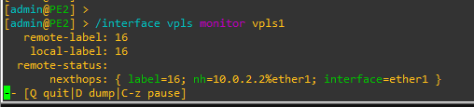
Figure 66: Output of vpls monitor PE2 Router

End-to-End Test: From CE1, run ping 192.168.10.2 OR From CE2, run ping 192.168.10.1. Success confirms the Layer 2 bridge is transparently passing traffic across the MPLS core.
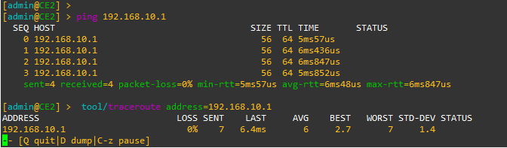
Figure 67: CE1 PING and TRACEROUTE Report

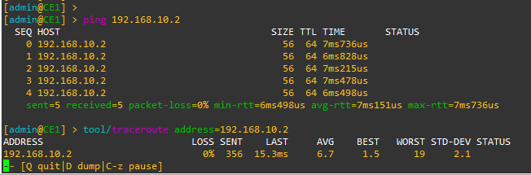
Figure 68: CE2 PING and TRACEROUTE Report

Troubleshooting Common Issues
- OSPF Not Converging: Check interface IPs, MTU (set MPLS MTU to 1508 if fragmentation issues).
- LDP Not Establishing: Ensure loopbacks are advertised in OSPF, transport-address set correctly.
- VPLS Down: Verify remote-peer is reachable, same vpls-id, LDP up.
- No Connectivity: Check bridge ports, ARP tables, and use /tool sniffer for packet captures.
- GNS3 Performance: Reduce RAM if crashes; your PC specs handle it well.
- MTU Issues: Set /mpls set dynamic-interface-mtu=1500 or adjust manually.
- Common Commands:
/log print for errors.
/mpls ldp bindings print for label info.

Wireshark Traffic

Identify basic protocols first
Before jumping into MPLS/VPLS, confirm that the traffic is capture correct.
ip
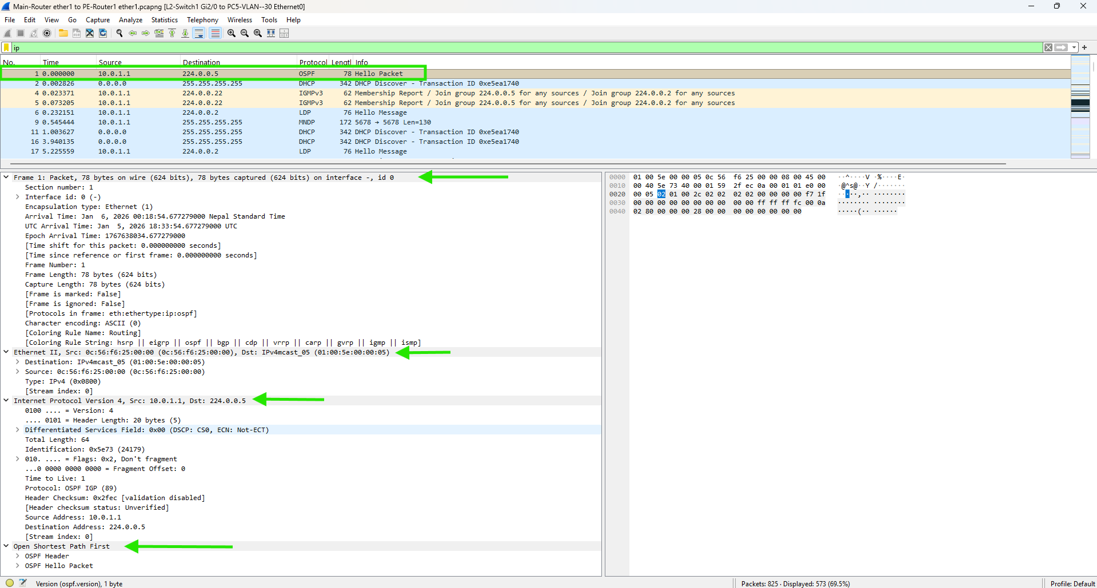
Figure 69
We will see normal ip traffic as show in upper figure
If you see nothing capture might be wrong interface or encapsulated only

Check OSPF (control plane)
OSPF is very important - it builds routes for MPLS.
ospf

We will see:
Hello packets
DBD (Database Description)
LSR / LSU / LSAck

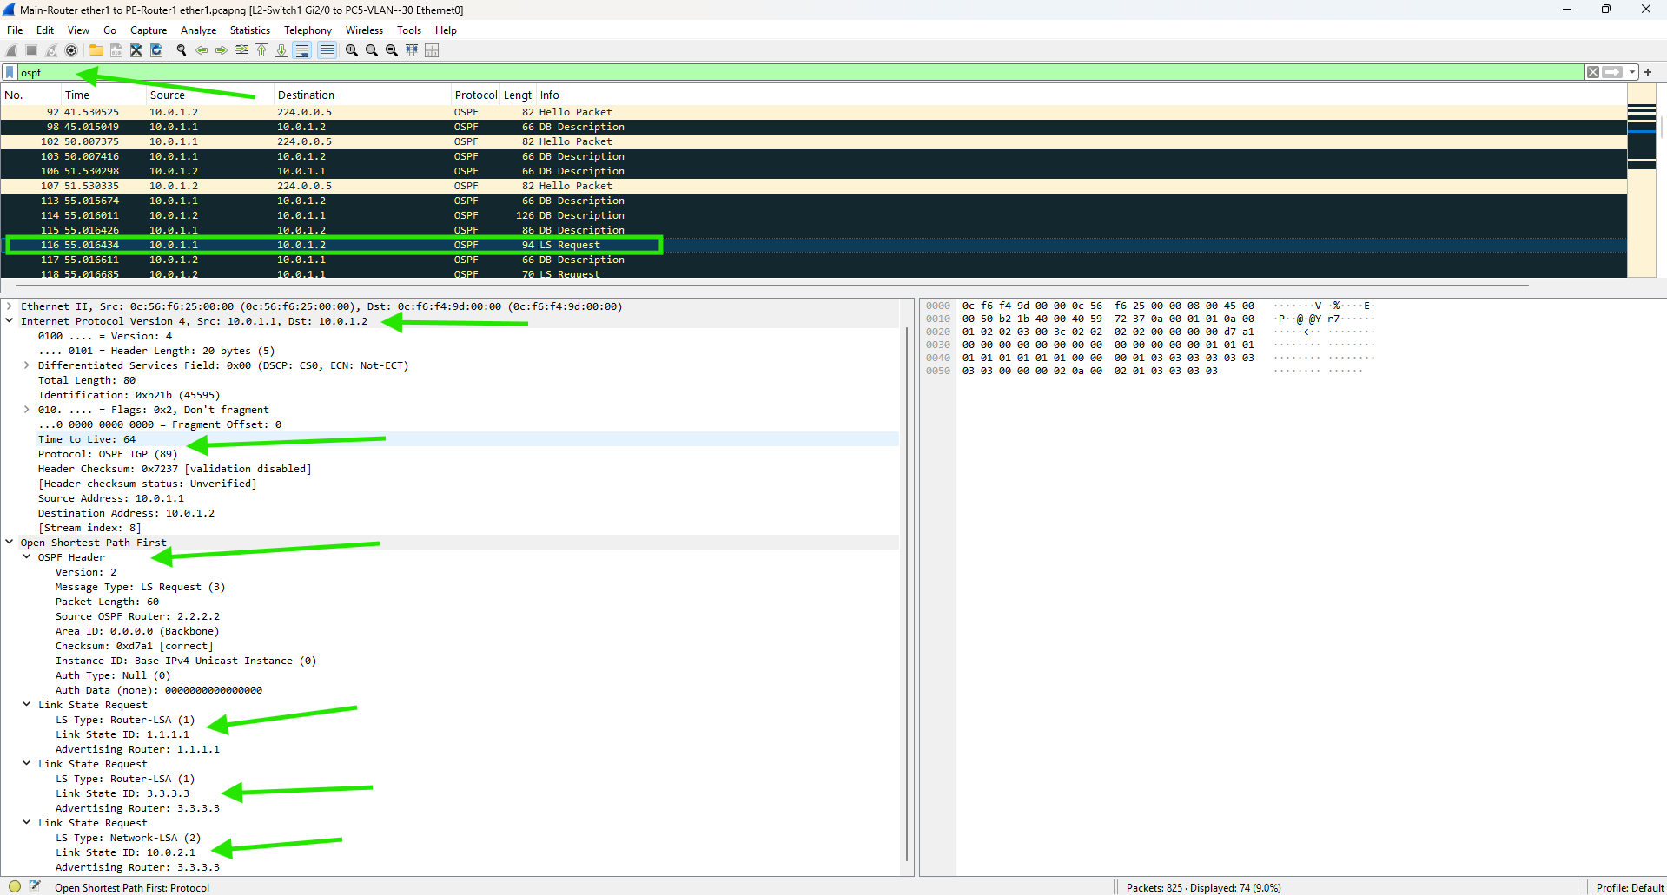
Figure 70
Check:
Router ID
Area ID
Hello Interval
Dead Interval
Link State Request

Verify OSPF Neighbor formation
Look specifically for Hello packets.
ospf && ospf.msg == 1
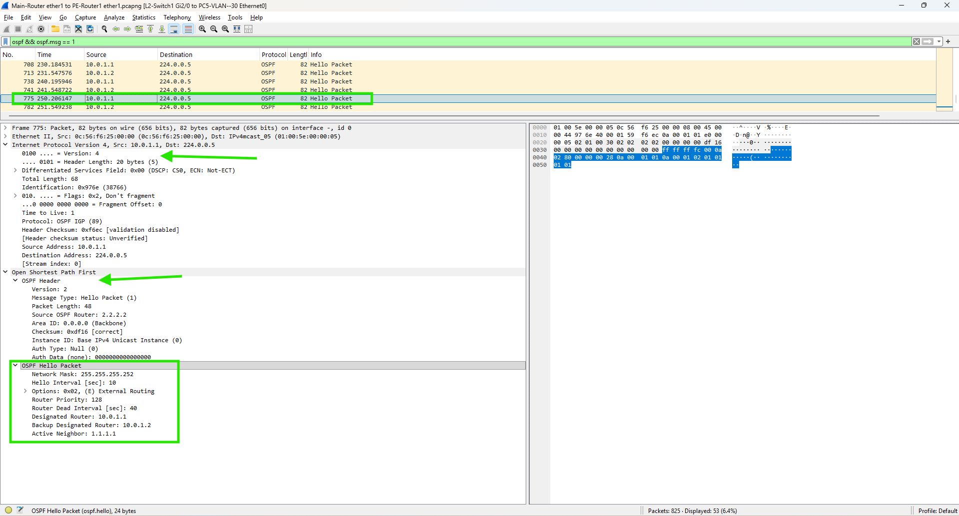
Figure 71
Check:
Source IP
Destination 224.0.0.5
Neighbor Router IDs

If neighbors don’t reach FULL, MPLS/VPLS won’t establish.

Check MPLS packets
mpls
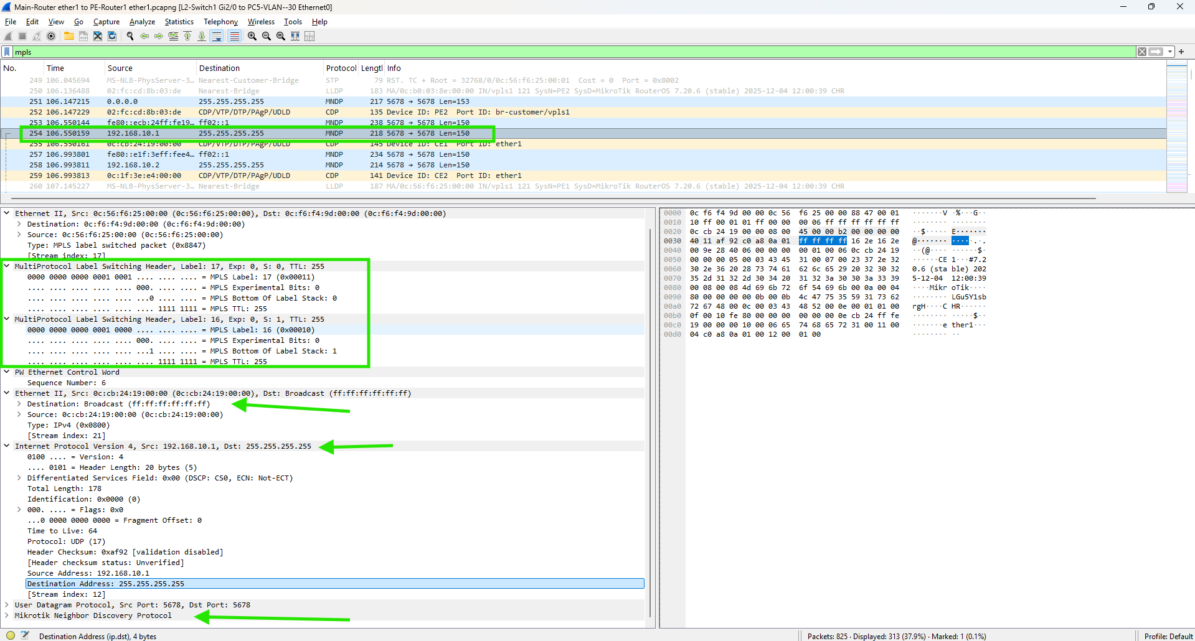
Figure 72

Check LDP (Label Distribution Protocol)
MPLS labels come from LDP (or RSVP).
ldp

You should see:
LDP Hello
LDP Initialization
Label Mapping messages

Destination ports:
TCP 646
UDP 646

No LDP = MPLS labels won’t exist

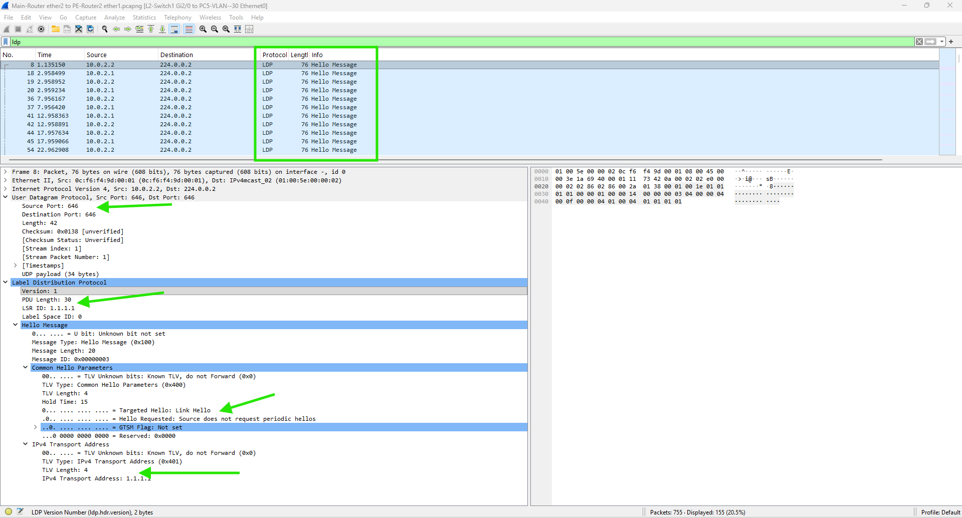
Figure 73

Verify VPLS traffic
VPLS usually runs over MPLS with Ethernet frames.

eth && mpls OR mpls && eth.type == 0x8847

Click packet on expand:

Ethernet
MPLS
Inner Ethernet Frame
If you see Ethernet inside MPLS, that’s VPLS

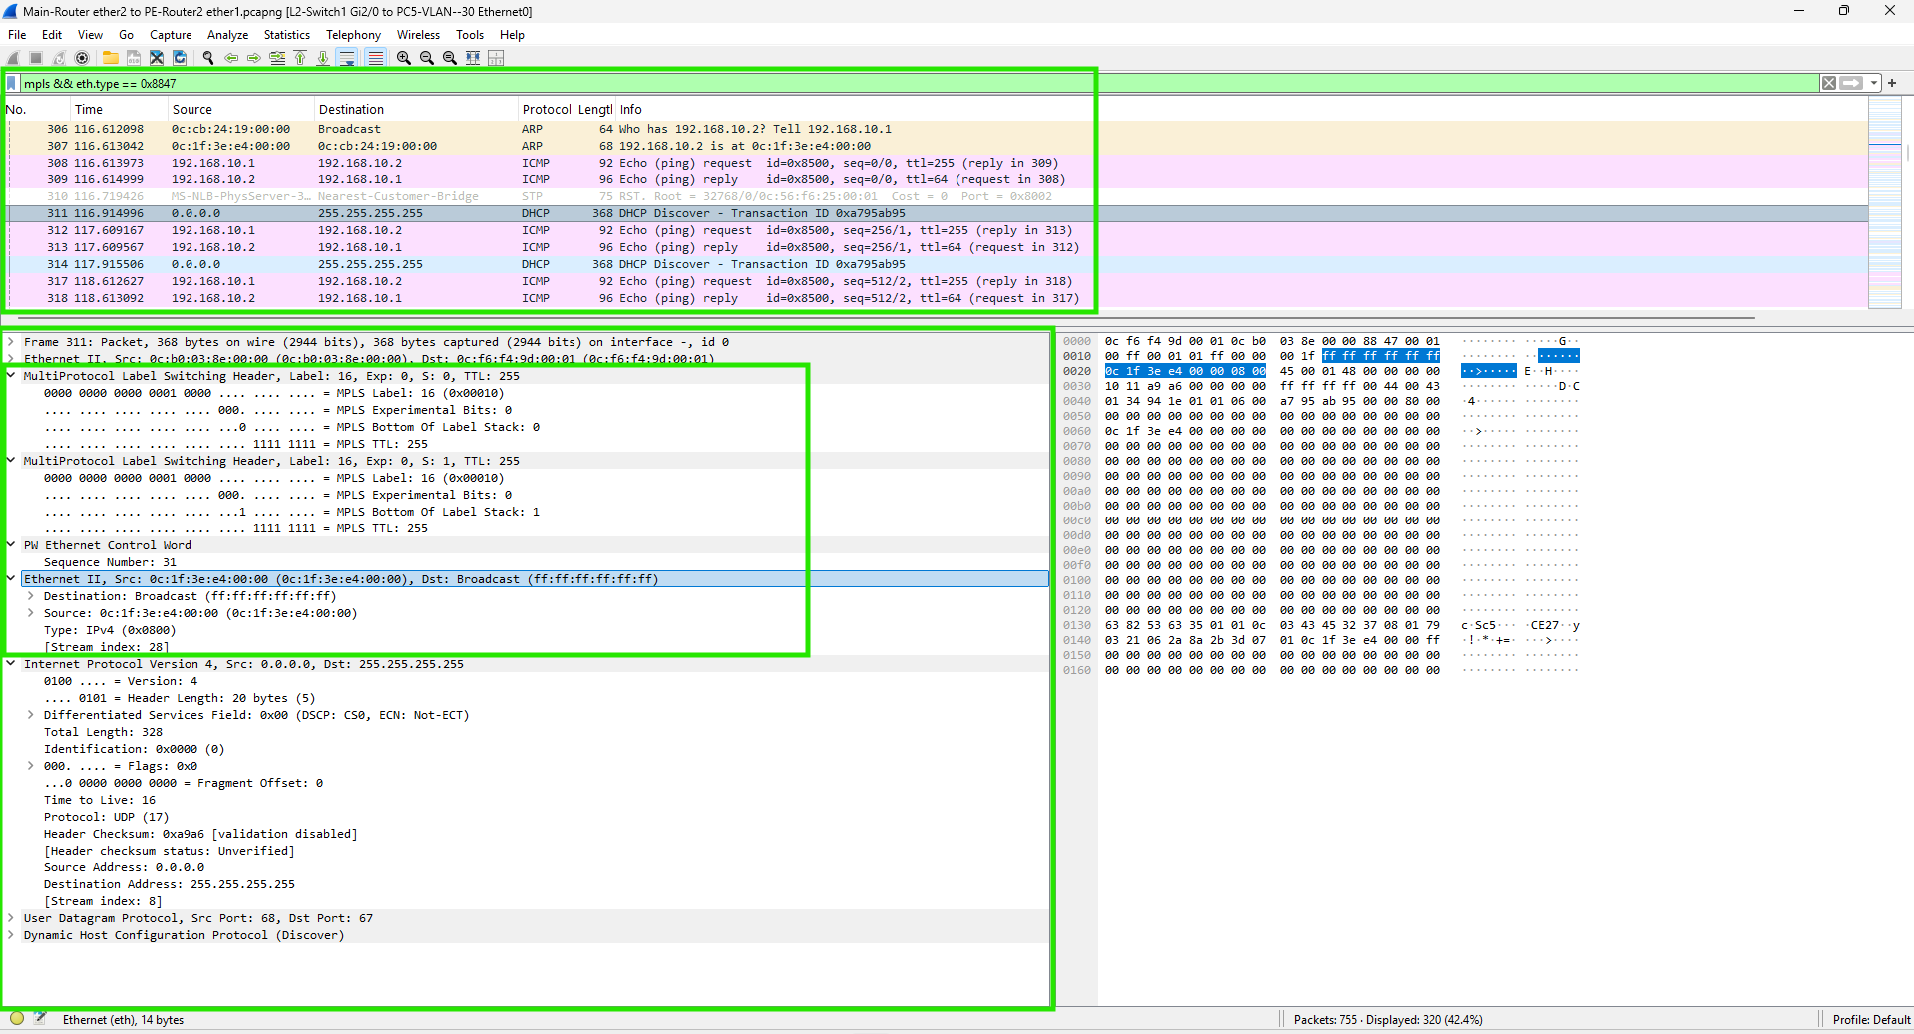

Check MAC learning (important for VPLS)
VPLS behaves like a switch.

arp or eth.dst == ff:ff:ff:ff:ff:ff

You should see:
ARP requests flooding
MAC addresses being learned

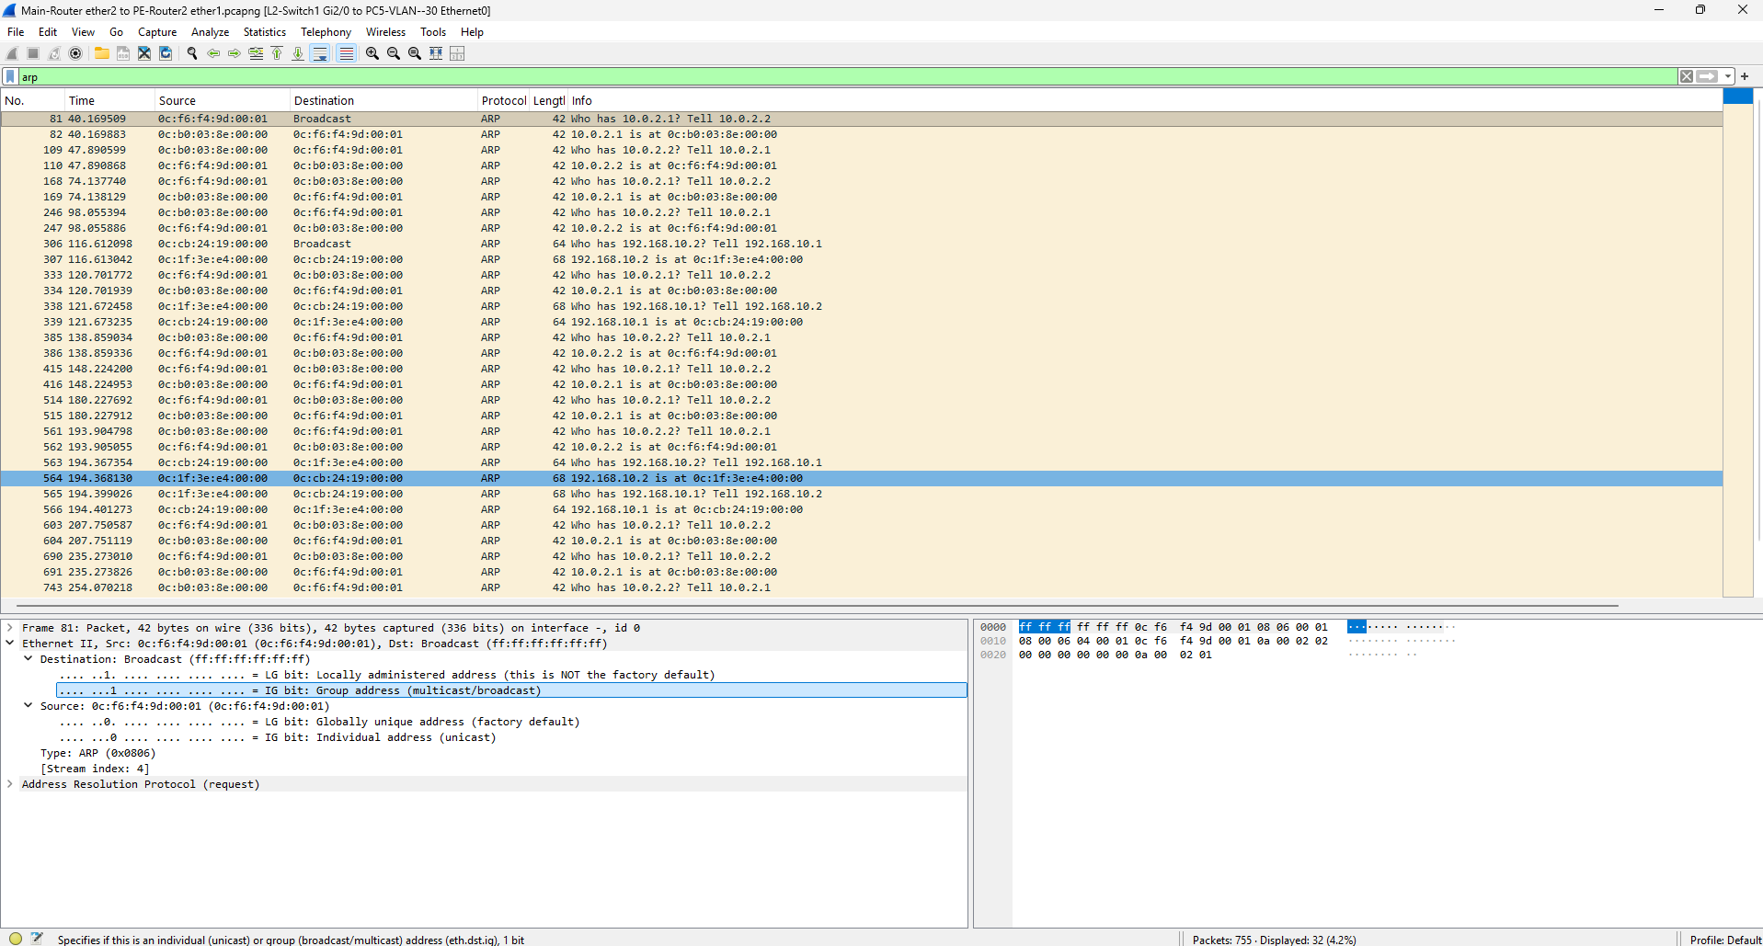
Figure 74

Conclusion
The successful implementation of this workshop demonstrates that MPLS and VPLS provide a robust, scalable solution for extending Layer 2 networks across a routed IP core. By decoupling the customer’s Ethernet traffic from the provider’s routing infrastructure, the network achieves a high degree of transparency and efficiency.
Key takeaways from this project include:
Infrastructure Synergy: The integration of OSPF for path determination and LDP for label switching creates a high-performance "label-switched" environment that minimizes CPU overhead on core routers.

Layer 2 Transparency: VPLS successfully creates a "virtual wire," allowing customer sites to communicate as if they were physically connected to the same local switch, supporting protocols that standard Layer 3 VPNs cannot easily transport.

The MTU Factor: The workshop highlights the critical importance of MTU overhead; by increasing the core MTU to 1508, the network avoids the performance degradation caused by packet fragmentation during encapsulation.

Ultimately, this MikroTik-based architecture provides a cost-effective and enterprise-ready blueprint for Service Providers looking to deliver seamless site-to-site connectivity while maintaining a simplified, IP-unaware core.

